TenantPro: Architecture, Implementation and Current State
Oct 30, 2026 · @Anush Kulal M
A technical report on TenantPro, a two-sided rent-management system built for the Indian residential rental market. It covers the architecture, the features that are actually built, the payment model, the security design, what the tests prove, and what is still missing.

Abstract
TenantPro is a working rent-management system with two sides to it, already deployed and in use. The client is React Native on Expo SDK 54; the server is Node and Express over MySQL. Together they come to 38,251 lines across 123 source files: 14,444 in the backend, 21,609 in the redesigned mobile client and 2,198 in eight test suites. The API exposes 87 endpoints over 22 tables. The client has 28 screens.
The one decision that shapes everything else is that money never passes through it. Rent goes straight from tenant to landlord, either by UPI or through a payment gateway wired to the landlord's own merchant account. That keeps the operator outside the RBI's payment-aggregator perimeter, which comes with an authorisation requirement and a ₹25 crore net-worth floor. It also means the platform bills nobody and holds nobody's funds.
An application that does not touch the money also cannot see it, so everything rests on an explicit confirmation step. A payment counts as real only once somebody other than the tenant vouches for it. There are two such vouchers: the landlord tapping Confirm, and the payment gateway answering a server-to-server query. Both run through the same settlement function, which is why they can never disagree about when a rent cycle has cleared.
The current build carries 386 assertions across six suites. Of those, 168 run end-to-end against a live server and a real MySQL instance, and 71 drive the compiled application inside a browser engine. The sections that follow cover the architecture, the feature set as it stands with screenshots as evidence, the payment and session-security models, how the verification was done, and the work that has been identified but not built.

1. Introduction
Most residential tenancy in India is run on paper, in WhatsApp threads and in the landlord's memory. Rent arrives by UPI transfer or in cash, and the record of it is a screenshot. The tenant who paid has no receipt their landlord has acknowledged. The landlord with six rooms has no dependable way of telling who is behind.
TenantPro works on the day-to-day side of that relationship, not the legal side. A landlord gets a roster of properties, rooms and tenants, with due dates worked out from each tenancy's own anniversary. The tenant gets a view of the same records from the other direction: what they owe, when it is due, what they have already paid, and which of it the landlord has acknowledged.
Three constraints did more to shape the build than any feature request did.
- The application cannot see money. There is no view of a bank account anywhere in it, so it is in no position to assert that a transfer happened. Until something outside the app vouches for it, a payment is only a claim. That is a matter of correctness, and no amount of engineering makes it go away.
- Collecting rent centrally is a regulated activity. Pooling tenants' rent in one account and paying it out again is payment aggregation as far as the RBI is concerned. Money is routed tenant-to-landlord for exactly that reason: to stay outside the perimeter.
- Native code cannot ship over the air. Updates reach the client through expo-updates, which can swap out JavaScript but not native modules. Any feature that needs a native SDK drags the release cadence of everything around it down with it, so those were turned down in favour of designs that ship like any other change.

2. System architecture
Every piece of information about a tenancy goes through the server. No part of the payment does. In the diagram below, the dashed band is the money path; it touches the tenant and the landlord, and nothing in between.
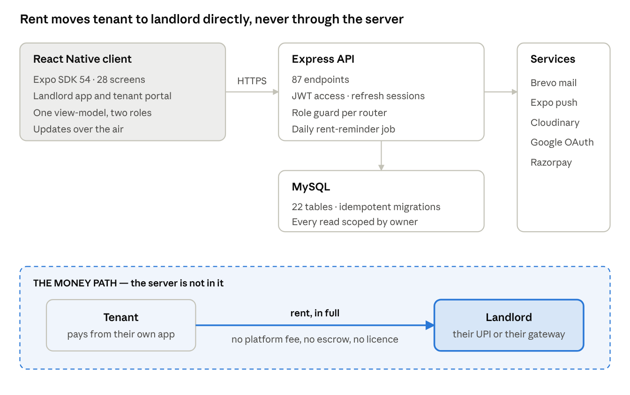
TenantPro architecture · client, API, data, services, and the money path outside all of them
One React Native codebase serves both roles. State goes through a single pure function, deriveVm(state, api), which turns server data into everything the screens render. That is what makes the interface testable without a device, and one of the suites in Section 7 exercises it directly.
The API is organised as routers, each with its role guard mounted once at the top rather than repeated in every handler. Landlord and tenant accounts sit in separate tables with their own auto-increments, so knowing who somebody is does not settle what they may do. requireOwner turns away a tenant token on a landlord route, and tenant handlers scope every query through the tenant_users to tenants link.
Schema changes apply themselves at boot, and apply safely more than once: schema.sql runs CREATE TABLE IF NOT EXISTS on every start, and column-level migrations go through ensureColumn and ensureIndex guards. No deploy has ever needed a manual migration step.

3. Landlord-side implementation
Every screenshot below comes from the running application, working against a seeded database of three properties, six rooms and ten tenants. None of the figures in them are placeholder text.

3.1 Portfolio overview
The landing screen answers the two questions that make a landlord open the app at all: who has paid, and who has not.
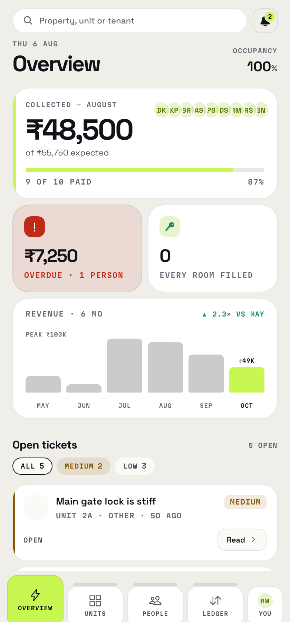
Collection is shown against what was expected rather than as a bare total: ₹48,500 of ₹55,750, nine of ten paid. A number with no denominator is not something anyone can act on. Overdue gets a card of its own, with a count of people attached. The revenue series is built from confirmed payments only. Claims that have been declared but not yet confirmed are left out on purpose, since including them would inflate income on nothing more than a tenant's word.
The bell carries a live count of whatever is waiting on a decision, which means declared payments and join requests.

3.2 The tenant roster
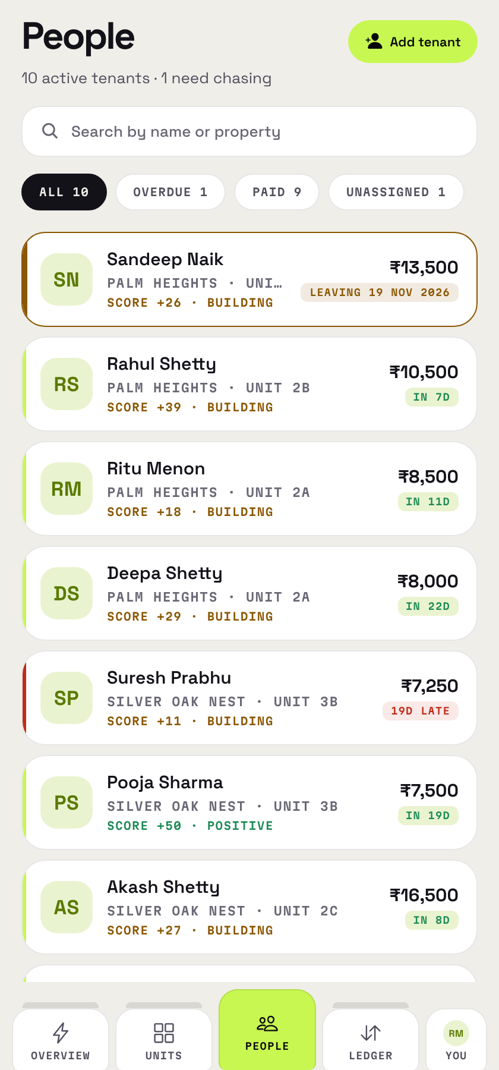
Each row carries the tenant's property and room, their share of the rent, a payment-behaviour score and a due-state chip: IN 7D, 19D LATE, or a leaving date once a tenant has given notice. The filter chips carry counts, so the spread is visible before any of them is tapped.
UNASSIGNED was not bolted on afterwards as an edge case. A tenant is allowed to exist without a room, and that state is reachable from the roster instead of being tucked away somewhere. The end-to-end suite checks that such a row renders without a broken room label.

3.3 Rooms and properties
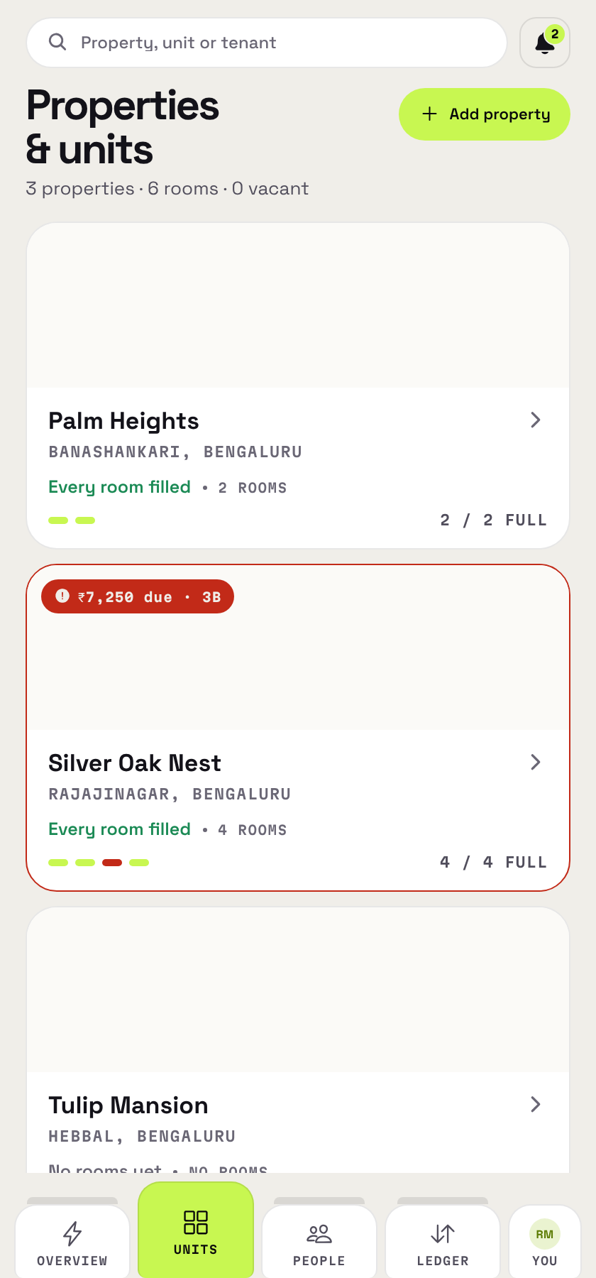
Properties hold rooms and rooms hold tenants, each room with its own rent, its capacity, and a split across occupants that can be equal or set by hand. A room's status follows its occupancy on its own. Notification preferences are per room, with email, SMS and WhatsApp switched independently, because a landlord rarely wants the same channel across a whole portfolio.

3.4 Ledger
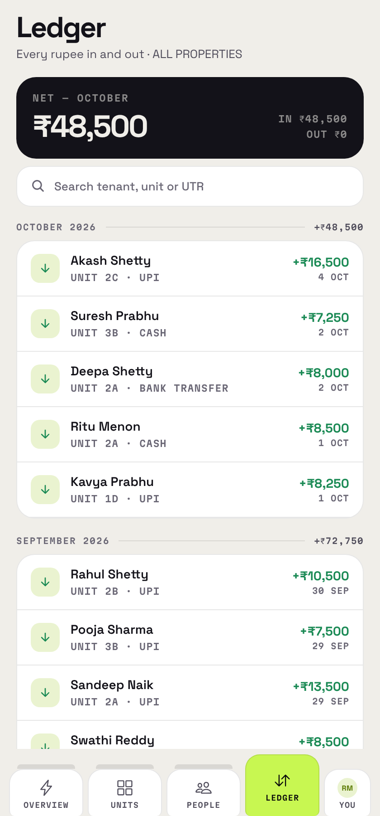
Every confirmed payment, searchable and narrowable to a single property. Each payment stores the due date it settled, captured at the moment of declaration. Without that field, "was this on time?" becomes unanswerable after the fact: confirming a payment moves the tenant's next-due date forward, and that overwrites the only evidence there was. Leaving it out is why the behaviour score once reported "None missed" for every tenant on the books.

3.5 Connecting a payment gateway
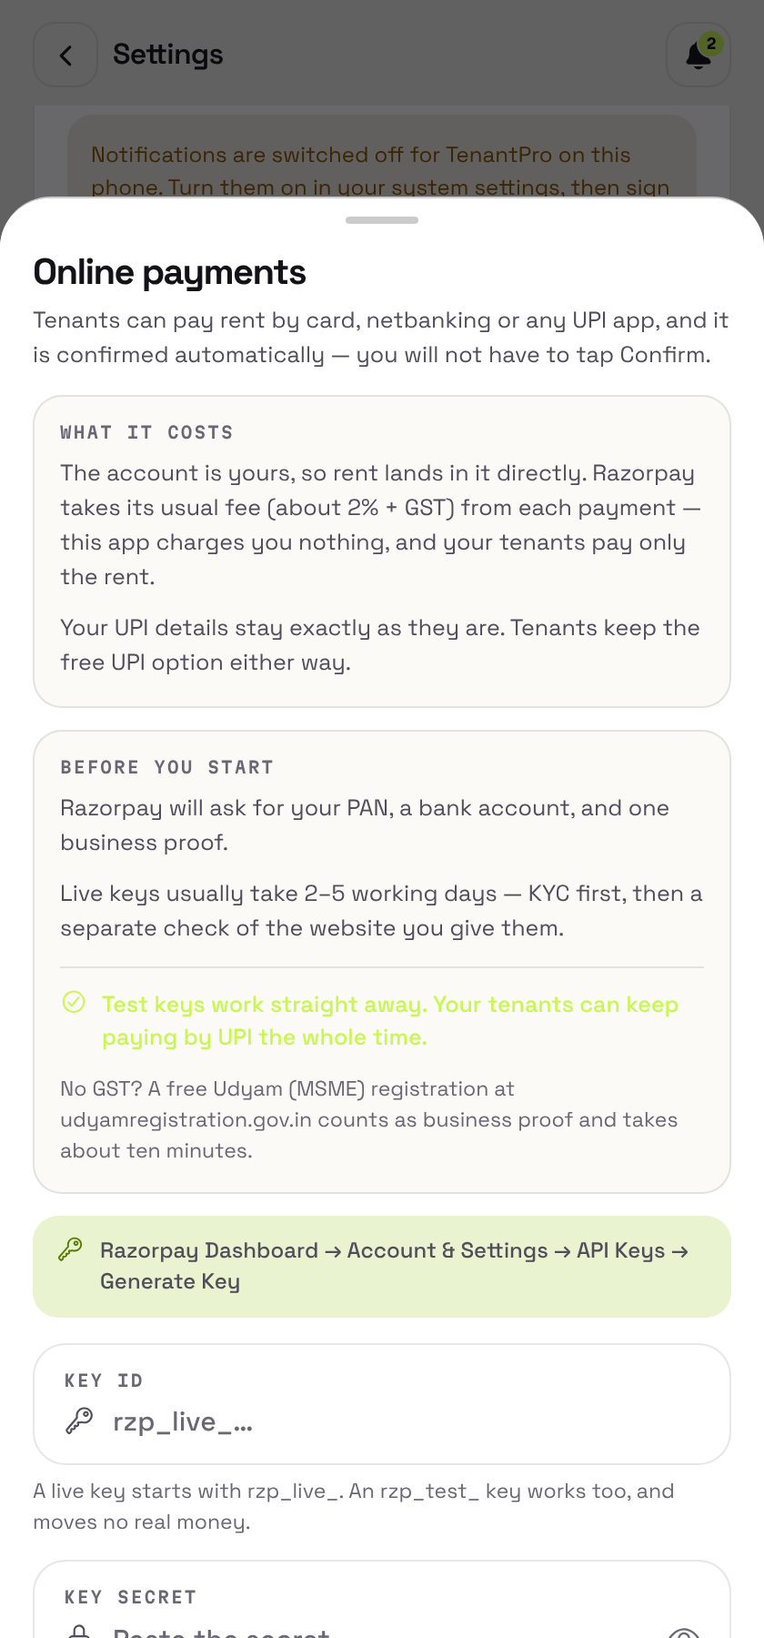
The sheet puts the price right next to the offer. Describing one without the other is how somebody switches on a 2% fee without noticing. It also spells out what the gateway is going to ask for before the landlord sets off: PAN, a bank account, one business proof, and two to five working days. It adds that test keys work straight away and that tenants can carry on paying by UPI the whole time. A landlord who expects five minutes and runs into a week concludes the application is broken.
Credentials are checked against the gateway before anything is stored, so a mistyped secret gets caught while the landlord still has the form in front of them. What is stored is sealed with AES-256-GCM, and it is never returned to any client.

3.6 Other implemented landlord features
- Join requests. A tenant asks to join a property using a code, and the landlord accepts or declines, assigning a room at the same time if they want to.
- Maintenance threads. A conversation per request, shared with the tenant, where status changes are recorded as events in the thread itself.
- ID documents. Proofs uploaded by the tenant. For tenants who have moved out, the preview is blurred and served under a short-lived token.
- Payment confirmation queue. Declared payments with enough context around them to decide, confirmed or rejected with a reason the tenant gets to read.
- Notice periods. A tenant's leave date, worked out on the server and shown to both sides.
- Daily rent reminders. An 8am job across email, push, SMS and WhatsApp, with every channel phrasing the same day the same way.
- Google sign-in, profile management with contact verification, and a reset for the demo account.

4. Tenant-side implementation
The tenant portal is not a cut-down version of the landlord app. It answers a different question: what do I owe, and has anyone acknowledged it? Getting in means a separate account type, with its own table and its own token role.

4.1 Home
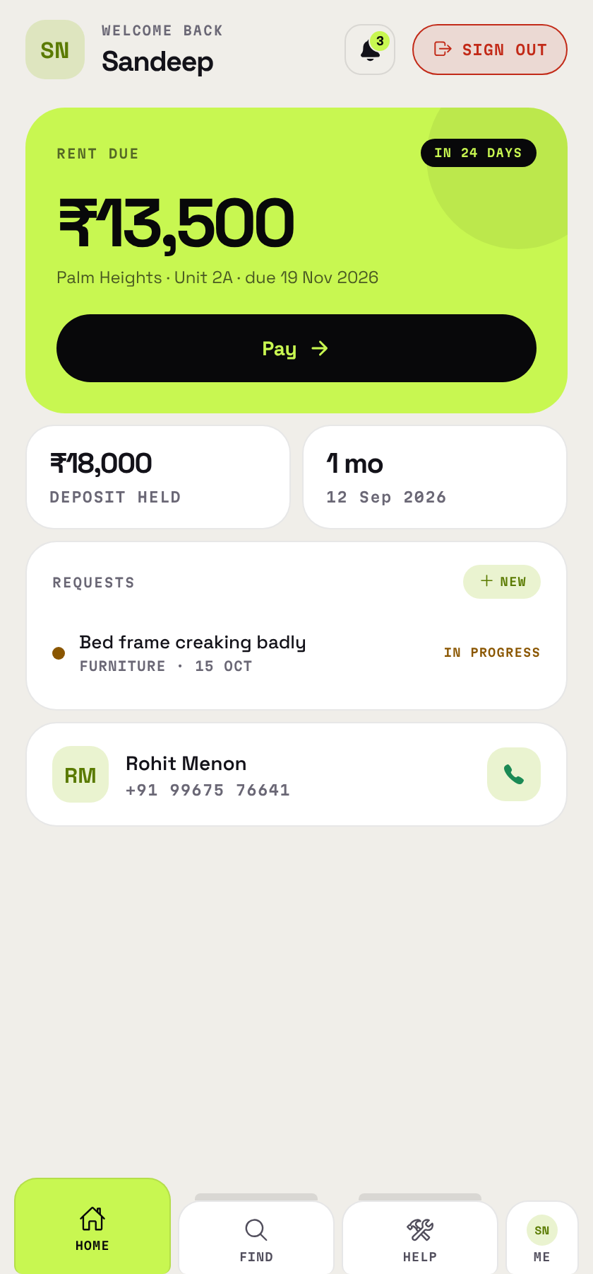
The rent card carries the amount, the property and room, the exact due date and a countdown to it. Deposit held and tenure sit underneath. Both are things tenants routinely cannot remember and have no other record of.
The bell works off the same payload the screen renders, not a separate unread count that could drift away from it. What shows up there: rent falling due, a landlord's reply on a maintenance thread, a payment confirmed or rejected, and the outcome of a join request. An alerts_seen_at timestamp tells an alert that is news apart from one that is merely still true. The server stamps it, so a phone with the wrong clock cannot silence its own alerts.

4.2 Paying rent
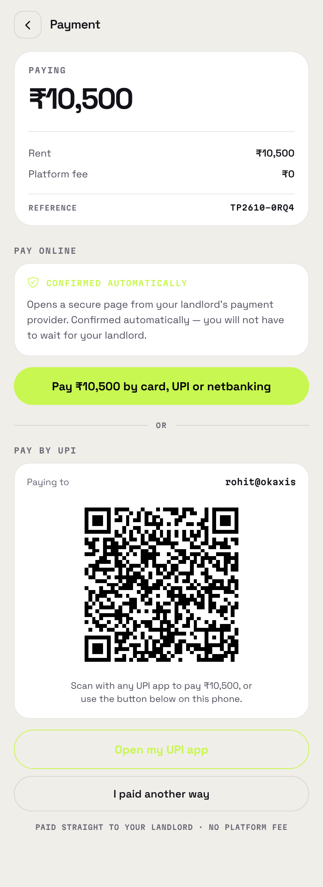
The screen shows what is owed, a reference and ₹0 as the platform fee. On both routes that figure is literally true.
Where the landlord has connected a gateway, Pay by card, UPI or netbanking comes first, since it is the only route that confirms itself. Below an OR divider sits the UPI route: the landlord's VPA, the amount and the reference, encoded as a QR that works when scanned from another phone, with a hand-off to the tenant's own UPI app for people paying on this one.
The two buttons look different on purpose. Two filled primary buttons amount to two primary actions, which is the same as having none. So the UPI button is outlined when something louder sits above it, and filled when it is the only thing on offer.
Coming back from a gateway page, the button reads Check my payment rather than "Yes, I paid". On that route the answer is not the tenant's to give.

4.3 Profile and payment history
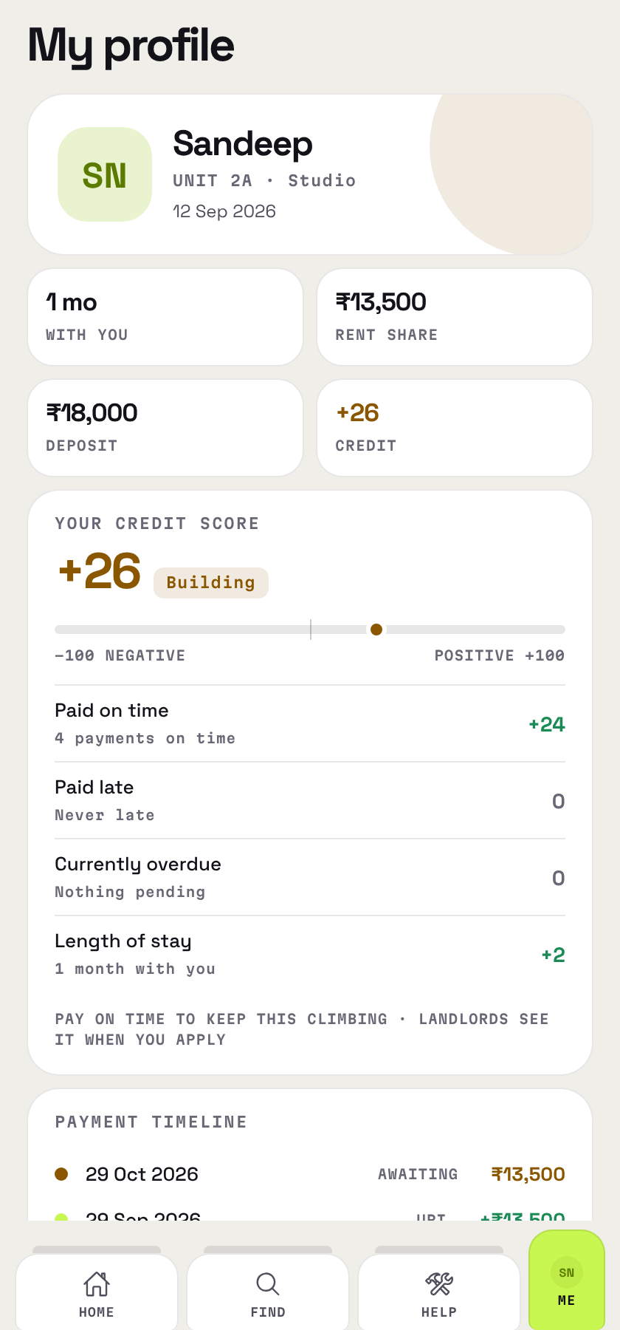
The behaviour score runs through the same code that produces the landlord's copy of it. Sharing the code is the whole point. A tenant looking at a different number from the one their landlord sees cannot argue with either of them. The factors are listed out instead of being boiled down to a dial, and where there is too little history to say anything, the screen says so. The alternative is a needle parked at zero, which reads like a verdict the tenant has earned.
The payment timeline is built from real rows. A claim still waiting on the landlord shows an amber AWAITING, not the green reserved for money that has actually arrived. Show the two alike and a tenant will believe their month is clear when it is not.

4.4 Maintenance
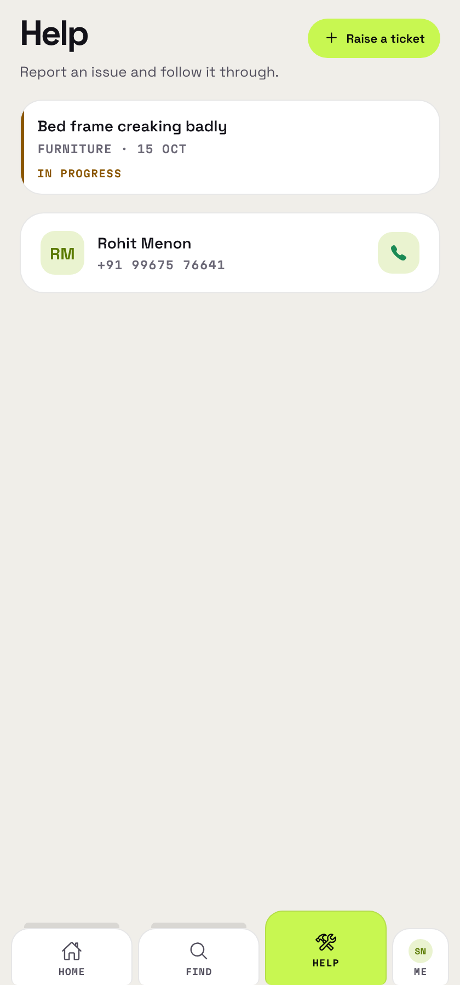
A tenant raises a request with a category, a priority and a photo if they have one, then follows it in a thread shared with the landlord. Status changes land in that thread as events, in order with whatever was said around them.

4.5 Other implemented tenant features
- Guest accounts. A tenant with no email, identified by a code, with a stay window attached. Expiry is enforced on the server, and the lock-out message offers the one action that resolves it.
- Claiming an account. A guest turns into a full account with a name, email and password.
- Joining a property. By scanning or typing an invite code, with the property shown before the request goes anywhere.
- Receipts. The full payment history, with status, reference and the rejection reason wherever one was given.
- Giving notice. The real dates are worked out and shown before anything is written, and the notice can be withdrawn afterwards.
- ID documents. Upload and removal, with a summary the landlord sees while deciding on a join request.
- Directions. To the tenant's own property, where the landlord has pinned it.

5. The payment and settlement model
There are three ways to move money between two parties on a platform. TenantPro uses the third, and that was a choice rather than an accident.
Model | Who holds the funds | Authorisation required | Example
Aggregator | the platform, in a ring-fenced escrow at a scheduled commercial bank | RBI payment-aggregator licence | Uber, Ola
Split settlement | the gateway, settling to linked sub-merchant accounts | held by the gateway, not the platform | Razorpay Route
Direct | nobody — payer pays payee | none | Namma Yatri, TenantPro
RBI rules do not let an aggregator keep customer funds in its own account. The money has to sit in a segregated escrow, where it earns the platform no interest and has to be settled out by a deadline. Getting that authorisation in the first place means clearing a net-worth floor in the tens of crores. TenantPro sidesteps the whole question by never receiving the money.

5.1 Two payment routes, both direct
UPI. The tenant's screen carries the landlord's own VPA, the exact amount and a generated reference, encoded both as a QR and as a upi:// intent. The tenant pays from whichever UPI app they already use. It costs everybody nothing.
Gateway. A landlord can connect their own Razorpay merchant account. The server then creates a Payment Link using their credentials, the tenant pays on Razorpay's hosted page, and the money settles to that landlord. Razorpay charges its fee to them, through their own account. The platform bills nothing, because it is party to nothing.
Payment Links were picked over Razorpay's React Native SDK for one reason: the SDK is a native module. A link is plain REST over HTTPS, which means the payment feature ships over the air like everything else.

5.2 The confirmation model
A payment starts out as a Declared row. That is a claim, and it clears nothing on its own. It becomes real when a second party vouches for it:
- the landlord taps Confirm, or
- the gateway is asked outright, server-to-server with the landlord's credentials, and says the link was paid.
Both paths end up in the same function, settlePayment, which flips the status and moves the tenant's next due date forward inside one transaction. Write it twice and the two copies will eventually disagree about when a month has cleared, so it is written once.
The gateway gets polled rather than trusted to call back. A webhook would mean every landlord configuring a URL and a secret in a dashboard, and most of them would never get to the end of that. The signed-webhook path does exist and is still supported; it is just the secondary route.

6. Authentication and session management
The session design went through three versions. The sequence is worth following, because each of the first two fixed something real and created the next problem on the way.
Stage | Access token | Can be revoked | Failure it solved | Failure it left
Original | 7 days, fixed | no | — | weekly logout for every user
Sliding | 30 days, renewed on use | no | the weekly logout | nothing could be cancelled
Current | 2 hours + refresh token | yes | revocation | instant revocation on the access path

6.1 Why a longer token was not the fix
Raising the lifetime from 7 days to 30 did not stop people being logged out. It made it happen monthly. A fixed lifetime counts from the last sign-in, which tells you nothing about whether somebody is still using the app. Open it every morning and you were thrown out on day 30, the same as somebody who had not opened it since February.
So the server re-issues the access token on any authenticated request once it is past half its life, handing it back on an X-Session-Token header that the client picks up. The new token's lifetime comes from the old one's exp - iat rather than from a constant. A guest session therefore keeps its own length, and older tokens keep theirs.

6.2 Refresh tokens and revocation
An access token is a signature and nothing more. The server consults no list when it verifies one, which is what makes it fast, and also meant there was no way to withdraw it. A stolen phone, a tenant who had moved out, a password change: none of them ended a session.
A session is now a row as well, holding a refresh token that is stored as a SHA-256 hash rather than as the token itself. Three properties of that design are worth naming:
- Rotation. Spending a refresh token gets you a replacement. A sixty-day secret that crosses the network on every reconnect is a long-lived credential. One that works once is not.
- Reuse detection. Rotation means the honest client is always holding the newest token, so a replay of a spent one says a copy is sitting somewhere else. Every session on the account is revoked. Getting that wrong in one direction costs somebody a sign-in; getting it wrong in the other costs them the account.
- Revocation on password reset. Resetting a password now ends every other session. Users had always assumed it did.
On the refresh path, revocation is immediate. On the access path it lags by at most the access token's two-hour life. Closing that last gap would mean a database read on every authenticated request, which is a cost almost nobody pays. The gain here is two hours where it used to be thirty days.

6.3 Client-side failure handling
If this design is going to fail badly, it will fail on the client. A 401 triggers one refresh and one replay. Only a 401 from the refresh endpoint itself ends the session; a 500, a timeout or a dead connection does not. The server answers 500 rather than 401 on its own faults deliberately, so that the client can tell the two apart.
The nastiest failure mode was concurrency. On a cold start the app fires eight requests at once, and if they all fail on the same expired token, the naive version issues eight refreshes. Seven of those replay a token the first one has already spent, the server reads that as theft, and every session ends. A feature built to prevent lockouts would have been causing them at scale. One shared in-flight promise is what stops it, and there is an assertion on that behaviour.

7. Verification
386 assertions across six suites stand behind the build. None of them uses a test framework. Each suite is a plain Node script that exits non-zero when something fails.
Suite | What it drives | Isolation | Assertions
secretbox | AES-256-GCM sealing of gateway credentials | pure | 24
session | token renewal, through the real middleware and the real interceptor | stubbed db | 41
gateway | gateway controllers | stubbed db and fetch | 72
vm.gateway | the real deriveVm, react-native stubbed | stubbed native | 52
refresh.client | the real axios interceptor: refresh, retry, and when not to sign out | stub adapter | 29
refresh.e2e | refresh tokens, reading the database directly | live server + MySQL | 42
api.e2e | all 87 endpoints | live server + MySQL | 126
ui.e2e | the compiled application in a browser engine | live stack + Chromium | 71

7.1 Seeded fixtures
A deterministic generator (scripts/seed.js) builds a portfolio that deliberately contains the rows which break screens and never turn up when you are looking for them: a tenant with no room, a guest with no email, a guest whose stay has already ended, rent overdue and due today and upcoming and never set at all, a payment declared and undecided, another rejected with a reason, maintenance threads where the landlord spoke last and others where the tenant did, a tenant who has given notice, and a property with no rooms in it. The PRNG is seeded, so any failing run can be reproduced.

7.2 What the browser suite does and does not cover
The UI suite runs the same JavaScript the phone runs: the same view-model, the same screens, the same API client and interceptors, laid out by react-native-web, which is what an Expo web export produces. What it cannot reach is anything sitting behind a native module, so camera, image picker, push delivery and the UPI intent hand-off are all out of scope. For those it prints SKIP instead of a pass, so a green run never claims coverage it does not have.

7.3 Defects found by the end-to-end runs
Driving every endpoint against a real database, and the application against a real browser, turned up five defects the unit tests had missed.
Defect | Severity | Status
Two of three endpoints accepting a unit_id checked ownership; the third did not, allowing one landlord's tenant to be filed into another's room | cross-account read | fixed — one shared check
A wrong password rendered "Your session expired", overriding the server's own WRONG_PASSWORD message | user-facing | fixed
Five required-field omissions produced HTTP 500 with a raw SQL error instead of a 400 | robustness | fixed
Renaming a property without its address crashed: NOT NULL column, coerced on insert but not on update | robustness | fixed
A network failure reaching the gateway was reported as a rejected credential | user-facing | fixed — transport failures now distinguished
Two more defects turned up in the test harnesses themselves, which is worth putting on the record. The first browser run never got past the permissions primer, and because its assertions were phrased as the absence of a string the primer also happened to lack, half the suite passed while testing nothing at all. Separately, the failure reporter crashed on a failure whose context was undefined and took down the run it was supposed to be reporting. The lessons are to assert on what should be there rather than on what should not, and to keep the failure reporter the dullest code in the file.

8. Limitations
Set out plainly, since each of these follows from a design decision rather than from an oversight.
The application cannot observe money. It never sees a bank balance, so a UPI payment stays a claim until the landlord confirms it. For landlords who connect a gateway, that goes away. For everyone else the confirmation step is structural.
Revocation lags by up to two hours on the access path. Closing the gap completely would mean a database lookup on every authenticated request.
Reuse detection can produce a false positive. If a client stores a new access token but fails to store the refresh token that came with it, the next request presents a spent token and every session gets revoked. The client-side write is transactional, but a device that loses its storage halfway through would still land here.
SMS is unconfigured. Phone verification needs a DLT registration with an Indian telecom operator, and that has not been done. Email and push are both live.
iOS has never been built. ios.bundleIdentifier is still unset, and the project has only ever produced Android artifacts.
Gateway onboarding is heavy. A landlord connecting Razorpay has to get through their KYC and a separate website verification, which realistically takes two to five working days. The in-app sheet now says so before they start, but it is still the biggest piece of friction in the product.
No automated regression gate. The suites exist and they pass, but nothing runs them on push. Verification is a manual step somebody has to decide to take.

9. Future scope

9.1 Identified and specified
Reply notifications on maintenance threads. When a tenant replies to a repair request, nobody is told: createRequestMessage makes no notify call, and the push rules have no owner-facing kind for a reply. The landlord-to-tenant direction already works.
A transaction around recordPayment. The landlord's own entry path inserts the payment and updates the due date in two separate statements. settlePayment, on the tenant-facing side, is already transactional. This path is not, and a failure between the two statements leaves a payment recorded against a date that never moved.
An automated test gate. The suites are reproducible and quick enough to run on every push. Wiring them into CI is configuration work rather than development work.
iOS. A bundle identifier and a first build.

9.2 Larger directions
Split settlement, once there are landlords other than the author. Razorpay Route would let landlords onboard as linked sub-merchants from inside the application, with the gateway doing their KYC. That would take away the onboarding friction described in Section 8. The cost is that funds would then pass through a platform account, which is a change of category and not of configuration, and the 2025 RBI directions restrict split settlement in ways that call for professional advice rather than inference. Worth coming back to when the user base justifies it. Not before.
Monetisation without entering the money path. The Namma Yatri precedent applies here almost directly. A flat per-landlord subscription keeps the operator out of the payment flow altogether, whereas a percentage of each transaction starts to look structurally like aggregation. There is a related legal nuance: models like this rest on selling access to software rather than on setting the price. In TenantPro the landlord sets the rent, and that is a position worth holding on to deliberately.
Deliverability. Transactional mail goes out from a Gmail address through Brevo's HTTPS API. A verified sending domain with SPF, DKIM and DMARC would improve inbox placement a good deal, for somewhere around ₹1,000 a year.
SMS and DLT. Phone verification needs an Indian DLT registration before any operator will carry template traffic.
Landlord announcements. A one-to-many message to everyone in a property ("water off Tuesday") was specified during the notification work and then never built. The alert infrastructure that would carry it is already there.

10. References
The code figures, endpoint counts and assertion totals in this report were measured from the repository at commit f065250 and from live test runs. None of them are estimates.
Regulatory and payment-model sources
- Nodal and escrow accounts under RBI rules — how aggregators are required to hold customer funds.
- RBI rewrites the payment aggregator rulebook — commentary on the Regulation of Payment Aggregators Directions, 2025.
- Razorpay Route — split settlement and linked accounts.
- Razorpay API keys — key generation, and the website verification required for live mode.
- Razorpay KYC documents by business type.
- Namma Yatri's zero-commission model — the direct-payment precedent discussed in Section 5.
Note on secondary sources. Several of the regulatory points above rest on consultancy and industry commentary rather than on the RBI's own text. Where this report leans on them, particularly for the net-worth thresholds and the restrictions on split settlement, the claims should be checked against the Directions themselves before anybody makes a structuring decision.

